**Compiler Design**

**EXP 4 - LEFT FACTORING**

**Rahul Kumar**

**RA1911003010699**

**AIM**

A program for implementation Of Left Factoring

**ALGORITHM**

1. Start
2. Ask the user to enter the set of productions
3. Check for common symbols in the given set of productions by comparing with:

A->aB1|aB2

1. If found, replace the particular productions with:

A->aA’

A’->B1 | B2|ɛ

1. Display the output
2. Exit

**PROGRAM**

#include<string.h>

#include<stdio.h>

#include<stdlib.h>

#include<conio.h>

void main()

{

char ch,lhs[20][20],rhs[20][20][20],temp[20],temp1[20];

int n,n1,count[20],x,y,i,j,k,c[20];

printf("\nEnter the no. of nonterminals : ");

scanf("%d",&n);

n1=n;

for(i=0;i<n;i++)

{

printf("\nNonterminal %d \nEnter the no. of productions : ",i+1);

scanf("%d",&c[i]);

printf("\nEnter LHS : ");

scanf("%s",lhs[i]);

for(j=0;j<c[i];j++)

{

printf("%s->",lhs[i]);

scanf("%s",rhs[i][j]);

}

}

for(i=0;i<n;i++)

{

count[i]=1;

while(memcmp(rhs[i][0],rhs[i][1],count[i])==0)

count[i]++;

}

for(i=0;i<n;i++)

{

count[i]--;

if(count[i]>0)

{

strcpy(lhs[n1],lhs[i]);

strcat(lhs[i],"'");

for(k=0;k<count[i];k++)

temp1[k] = rhs[i][0][k];

temp1[k++] = '\0';

for(j=0;j<c[i];j++)

{

for(k=count[i],x=0;k<strlen(rhs[i][j]);x++,k++)

temp[x] = rhs[i][j][k];

temp[x++] = '\0';

if(strlen(rhs[i][j])==1)

strcpy(rhs[n1][1],rhs[i][j]);

strcpy(rhs[i][j],temp);

}

c[n1]=2;

strcpy(rhs[n1][0],temp1);

strcat(rhs[n1][0],lhs[n1]);

strcat(rhs[n1][0],"'");

n1++;

}

}

printf("\n\nThe resulting productions are : \n");

for(i=0;i<n1;i++)

{

if(i==0)

printf("\n %s -> %c|",lhs[i],(char)238);

else

printf("\n %s -> ",lhs[i]);

for(j=0;j<c[i];j++)

{

printf(" %s ",rhs[i][j]);

if((j+1)!=c[i])

printf("|");

}

printf("\b\b\b\n");

}

}

**OUTPUT**

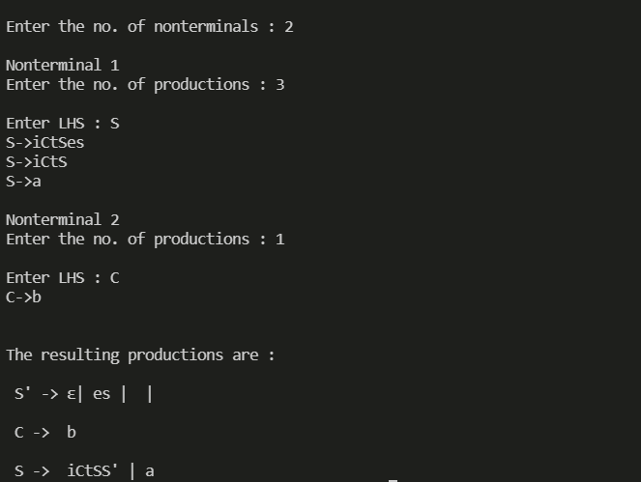

**RESULT**

A program for implementation Of Left Factoring was compiled and run successfully